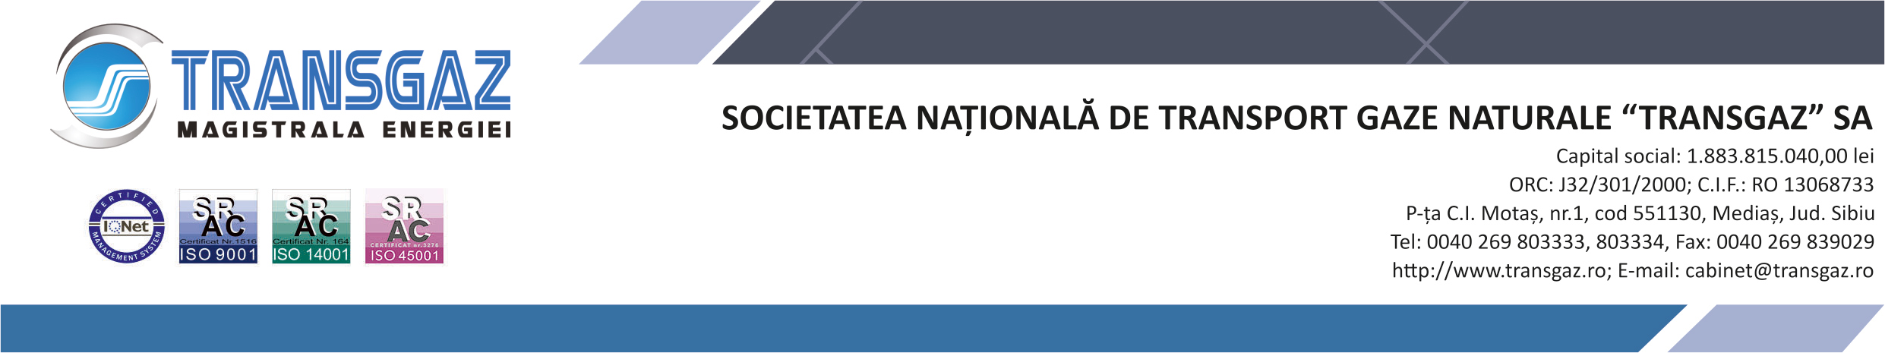

17 May 2024

RELEASE

SNTGN TRANSGAZ SA reports that in accordance with the provisions of Directive 2009/73/EC of the European Parliament and of the Council concerning common rules for the internal market in natural gas, Art. 22(1): ”Every year, transmission system operators shall submit to the regulatory authority a ten-year network development plan based on the current and forecasted supply and demand, after prior consultation of all relevant stakeholders”, the company published today, 17 May 2024, on its own webpage the Plan for the Development of the National Gas Transmission System for the period 2024-2033, for public consultations.

Please note that comments to the Plan for the Development of the National Gas Transmission System for the period 2024-2033 may be submitted to the email address cabinet@transgaz.ro by 17 June 2024, at the latest.

COMMUNICATION DEPARTMENT

