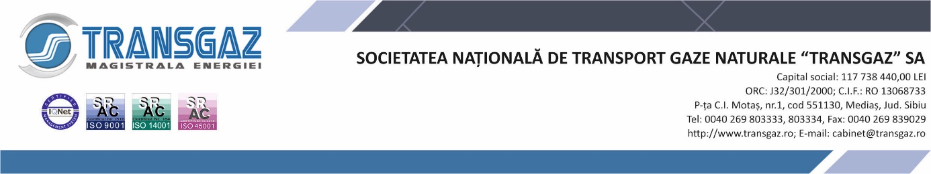

List of documents of public interest and list of documents prepared and/or managed by SNTGN TRANSGAZ SA
- List of documents of public interest communicated automatically, pursuant to Article 5 of Law 544/2001

- Normative acts governing the organization and functioning of SNTGN TRANSGAZ SA;
- Organisational structure, departmental tasks, operating programme, programme of SNTGN TRANSGAZ SA;
- Names and surnames of the persons in the management of SNTGN TRANSGAZ SA (their CVs) and of the person responsible for the dissemination of public information;
- Declarations of assets and interests;
- Contact details of SNTGN TRANSGAZ SA, i.e.: name, registered office, telephone and fax numbers, e-mail address and website address;
- Financial sources, budget and balance sheet;
- Its programmes and strategies;
- List of documents of public interest;
- List of the categories of documents created and/or managed in accordance with the law;
- The procedures for appealing against the decision of SNTGN TRANSGAZ SA, in the event that the person considers that he/she was harmed in terms of the right of access to the information of public interest requested;
- Other information published on the website www.transgaz.ro.

II. List of categories of documents prepared and/or issued by the company, according to Article 5 of Law 544/2001:
- Documents prepared by the company:
The National Energy Regulatory Authority - the natural gas domain: https://www.anre.ro/ro/gaze-naturale/informatii-de-interes-public
The Bucharest Stock Exchange - laws and regulations:
https://bvb.ro/Regulations/LegalFramework/LawsAndRegulations
The Bucharest Stock Exchange - BSE regulations:
http://www.bvb.ro/Regulations/LegalFramework/BvbRegulations

The National Agency for Mineral Resources:
http://www.namr.ro/legislatie/legislatie-nationala/
The Ministry Economy:
http://www.economie.gov.ro/#
The Ministry of Public Finance:
http://www.mfinante.gov.ro/pagina.html?pagina=acasa The Ministry of Energy:
http://energie.gov.ro/
European Funds:
http://www.fonduri-ue.ro/legislatie-nationala
- The main normative acts regulating the natural gas sector;
- Performance standard for natural gas transmission system service;
- Network Code for the National Gas Transmission System;
- Timetable for the annual and quarterly transmission capacity booking process at National Gas Transmission System entry/exit points;
- Provisions on capacity allocation, congestion management and procedures for anti-stocking and reuse of transmission capacity;
- Methodology for setting regulated tariffs for natural gas transmission services;
- Tariffs for the provision of natural gas transmission services;
- Regulation for metering the quantities of natural gas traded in Romania;
- Rights and obligations of network users;
- Balancing rules and imbalance tariffs;
- Other documents managed by the company (economic, financial, legal, corporate governance).

b. Documents issued by the company:
- Half-yearly, quarterly, annual reports;
- National Gas Transmission System Development Plan;
- Other documents managed by the company that may be communicated automatically.

- The following information is exempted from the free access of citizens, provided for in Article 1 and Article 11^1 respectively, according to Article 12 of Law 544/2001:

- Information in the field of national defence, security and public order, if it is part of classified information according to the law;
- Information concerning the deliberations of the authorities, as well as information concerning Romania's economic and political interests, if it is part of classified information, according to the law;
- Information on commercial or financial activities, if their publication would infringe intellectual or industrial property rights and the principle of fair competition, in accordance with the law;
- Information on personal data according to the law;
- Information regarding the procedure during the criminal or disciplinary investigation, if the outcome of the investigation is jeopardised, confidential sources are revealed or the life, physical integrity or health of a person is endangered as a result of the investigation carried out or in progress;
- Information relating to court proceedings, if its disclosure would undermine due process or the legitimate interest of any party to the proceedings;
- Information whose publication undermines youth protection measures.

- List of information exempted from disclosure in order to comply with the principle of confidentiality:

- Administrative control reports;
- Internal operational memos;
- Complaints and disciplinary investigation documents;
- Telephone numbers of company employees and information on their non-business activities;
- Complaints, requests and enquiries from staff and other interested parties;
- General incoming and outgoing mail register;
- Register for the registration of requests and responses on access to information of public interest;
- Register of records of transfers abroad;
- Register of cases (requests, complaints or referrals);
- The register of decisions;
- Special register of secret and confidential correspondence;
- The archive register;
- Inventory register of assets;
- Correspondence with domestic and international public institutions;
- Files on litigation in which the institution is involved and the names of the persons supporting the interests of the company in such litigation;
- Minutes of findings;
- Reports drawn up following control and investigation actions;
- Hearing notes;
- Correspondence with economic operators, natural gas transmission system operators and the persons concerned;
- Documents whose disclosure to the public may affect the right to privacy, family and private life or which may influence cases before the courts;
- Decisions of an internal nature issued by the company's management;
- Internal provisions issued by the heads of functional structures within the company;
- Payroll statements;
- Annual and quarterly investigation plans;
- Other internal documents relating to the company's activity, which require the compliance with the principle of confidentiality.

- Any person has the right to request and obtain from public authorities and institutions, under the conditions of this law, information of public interest, according to Article 6 of Law 544/2001.

The written request for information of public interest shall include the following elements:
- the public authority or institution to which the request is addressed;
- the information requested in such a way as to enable the public authority or institution to identify the information of public interest;
- the surname, first name and signature of the applicant and the address to which the reply is requested.
- the e-mail address to which requests under Law 544/2001 on free access to information of public interest are sent is comunicare@transgaz.ro .

According to Article 9 of Law 544/2001, if the request for information involves making copies of documents held by the company, the cost of copying services shall be borne by the applicant, in accordance with the law.

