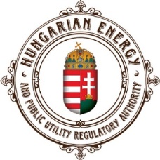
PRACTICAL INFORMATION

ROHUAT pipeline project
Shipper event
08. March 2017
10h – 14h

Budapest, Hungary
MEETING VENUE

Hungarian Energy and Public Utility Regulatory Authority (HEA)
(Magyar Energetikai és Közmű-szabályozási Hivatal)
Conference Room, First Floor
1054 Budapest, Bajcsy Zs. u. 52.

https://www.google.hu/maps/place/Bajcsy-Zsilinszky

How to reach the venue from Budapest Airport

1. Airport Shuttle Bus
There are Airport Shuttle - Minibus Desks at Terminal 2A and 2B. All Minibuses arrive at and depart from the Terminals’ Main Entrance. Reservations can be made in person at the Airport Shuttle-Minibus Desks or at least 12 hours before your flight departure via online reservation system. The Reservation Code received after payment enables the passenger to register at the Airport Shuttle-Minibus Desk at a separate e-Ticket Lane with no queue.
Contact:
Phone (24 hours a day): +36 1 296 8555
www.airportshuttle.hu/en
http://bud.hu/english

2. Taxi
Please, avoid using non-regulated providers offering taxi service at the terminal buildings!

Reservations can be made in person at the FŐTAXI (official transport partner of Budapest Airport) booths located at the exits at Terminals 2A and 2B. At the taxi rank in front of the stands, taxis are parking continuously waiting for passengers. Taxi prices in Budapest are regulated: there is a fixed km charge of 280 HUF/Km in addition to the one-off basic fee of 450 HUF and the waiting charge of 70 HUF/min. A ride to the city center from the airport should typically cost around 6500 HUF (app. 22 EUR) depending on traffic conditions.
Contact :
Főtaxi
Phone: +36 1 222 2222
Mobile phones: +36 20 222 2222, +36 30 222 2 222, +36 70 222 2 222
Website: www.fotaxi.hu

3. Public Transport

Information on public transportation route from Airport to HEA is under the following link:
https://www.google.hu/maps/dir/Budapest+Airport,+Budapest

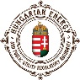
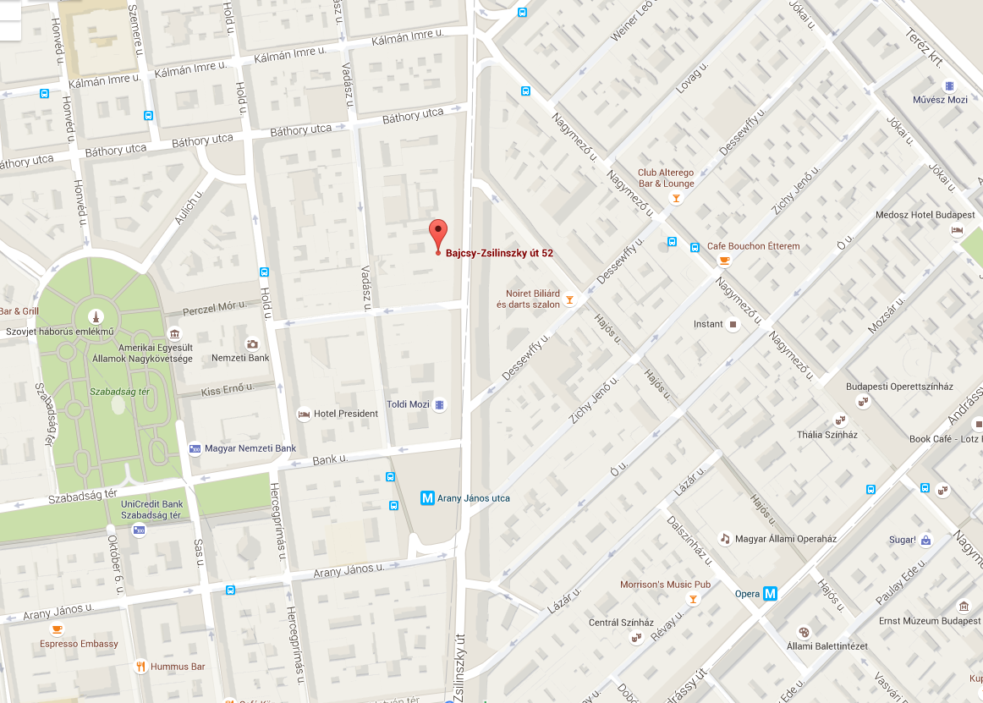

ACCOMMODATION

Recommended hotels, walking distance from the HEA:

Hotel President /

Address: Hold u. 3-5. 1054 Budapest, Hungary

Downtown Budapest now has a new boutique hotel that offers luxury and elegance at a reasonable price. Hotel President has four and five-star rooms and services close to the Parliament and Saint Stephen's Basilica, 1 km (0.6 mi) from the city center. Corporate rate for double room is from 85 Euro per room/night, breakfast, welcome drink, wellness use, vat are included.

E-mail: hotel-president-budapest@email

http://www.hotelpresident.hu/en/

Hotel Parlament

Address: Kálmán Imre u. 19. 1054 Budapest, Hungary

Hotel Parlament is a new delicate four star hotel in the business center of Budapest designed in harmony of the minimal-art style beauty. 1.2 km (0.8 mi) from city center. Single rooms are available from Euro 110 (double Euro 120) per room /night, breakfast, wellness use, vat and tax on tourism, Wi-Fi as well as coffee, tea, mineral water in the Lounge Bar up to 7 pm are included in the price.

E-mail: hotelparlament@email

http://www.parlament-hotel.hu

Kempinski Hotel Corvinus Budapest

Address: Erzsébet tér 7-8. 1051 Budapest, Hungary

Kempinski Hotel Corvinus, luxury 5-star hotel, located in the city center of Budapest offers outstanding facilities for businessmen and leisure travelers: spacious 349 rooms and suites, fine dining in Restaurant Giardino and NOBU Budapest, 500 square meters Kempinski SPA, being 0.4 km (0.3 mi) from the city center. Single rooms are available from 199 Euro (double Euro 212) per room/night, breakfast, vat and tax on tourism are included.

E-mail: hotelkempinskicorvinus@email

http://www.kempinski.com/en/budapest/hotel-corvinus

Design Hotel Marmara

Address: Nagy Ignác u. 21. 1055 Budapest, Hungary

Hotel Marmara welcomes guests in the heart of Budapest, offering the leisure and luxury of the Eastern world right in the middle of the bustling city. The Western Railway Station, the building of the Parliament, and the Danube river with Margaret Island are all within a few minutes' walking distance, so the neighbourhood abounds in historical, cultural and tourist site, being 1.6 km (1 mi) from the city center. Double rooms are available from 89 Euro per room / night with breakfast. Vat and tax on tourism are excluded.

E-mail: hotelmarmara@email

http://www.marmara.hu

Hotels on the google maps: https://www.google.hu/maps/

General information

- Information on Budapest: http://budapest.hu/sites/english
- Currency: Hungarian forint (HUF), 1 EUR = app. 315 HUF
- Time zone: GMT +1
- Smoking is prohibited in indoor public areas as well as around bus and tram stops

If you need any assistance, do not hesitate to contact us: nkeht@mekh.hu (attention: Mr. Andor Szilárd Ávéd)

