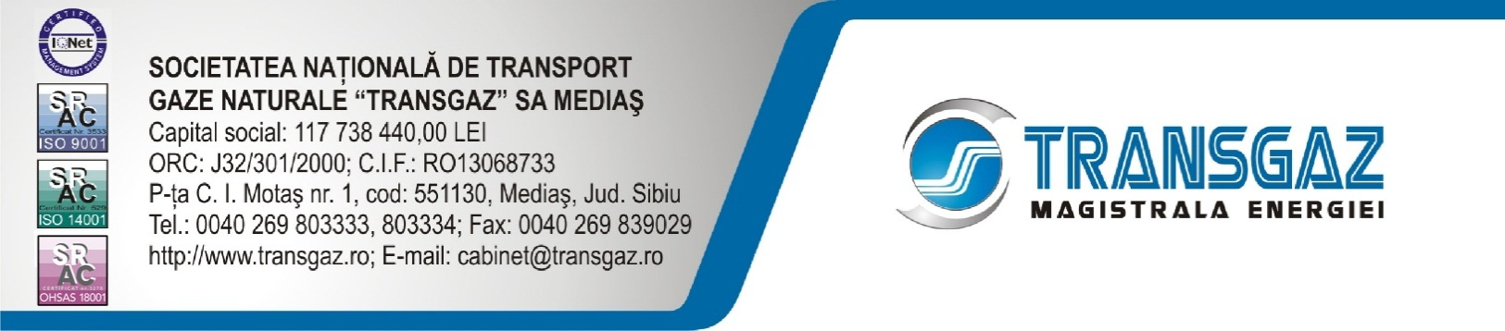

PRESS RELEASE

Transgaz concluded this month the Interconnection Agreement for the interconnection point Negru Voda 1 with the Bulgarian transmission system operator (Bulgartansgaz EAD) and the Interconnection Agreement for the interconnection point Isaccea 1 with the Ukrainian transmission system operator (Ukrtransgaz). Both points are cross-border interconnection points related to the Transit 1 pipeline (Isaccea - Negru Voda).
These agreements will enter into force on 1 October 2016 and they stipulate the assurance of physical gas flows in the direction Ukraine - Romania - Bulgaria and virtual reverse flows. Currently physical reverse flows cannot be ensured, this goal will be analysed by the transmission system operators and implemented in the coming years and the interconnection agreements will be amended accordingly.
The existence of interconnection agreements between neighbouring transmission system operators for cross-border interconnection points between EU Member States is an obligation imposed by the Regulation (EU) 2015/703 establishing a network code on interoperability and data exchange rules.
These agreements provide both the technical details related to the operation and exploitation of the stations associated to the interconnection points and the rules for the nomination, matching and allocation of gas quantities, transparent and non-discriminatory rules applicable in the relationship between the operators and all the potential network users.
It is worth mentioning that the conclusion of these agreements is one of the goals of CESEC’s initiative launched last year by the European Commission to facilitate the operation of the integrated European market in South-Eastern Europe.
We would also like to emphasize that the information included in these agreements, which are relevant for network users, will be published on Transgaz’ website.

Corporate Communication Department

